Unit 9 – Charts Worksheet and Analysis

# Exercise 9.1D: Bar Chart – Brand Preferences

Dataset Used: Brandprefs.xlsx

Variables: Area (1, 2, or 3), Brand (A, B, Other)

Chart Type: Bar Chart (Nominal data)

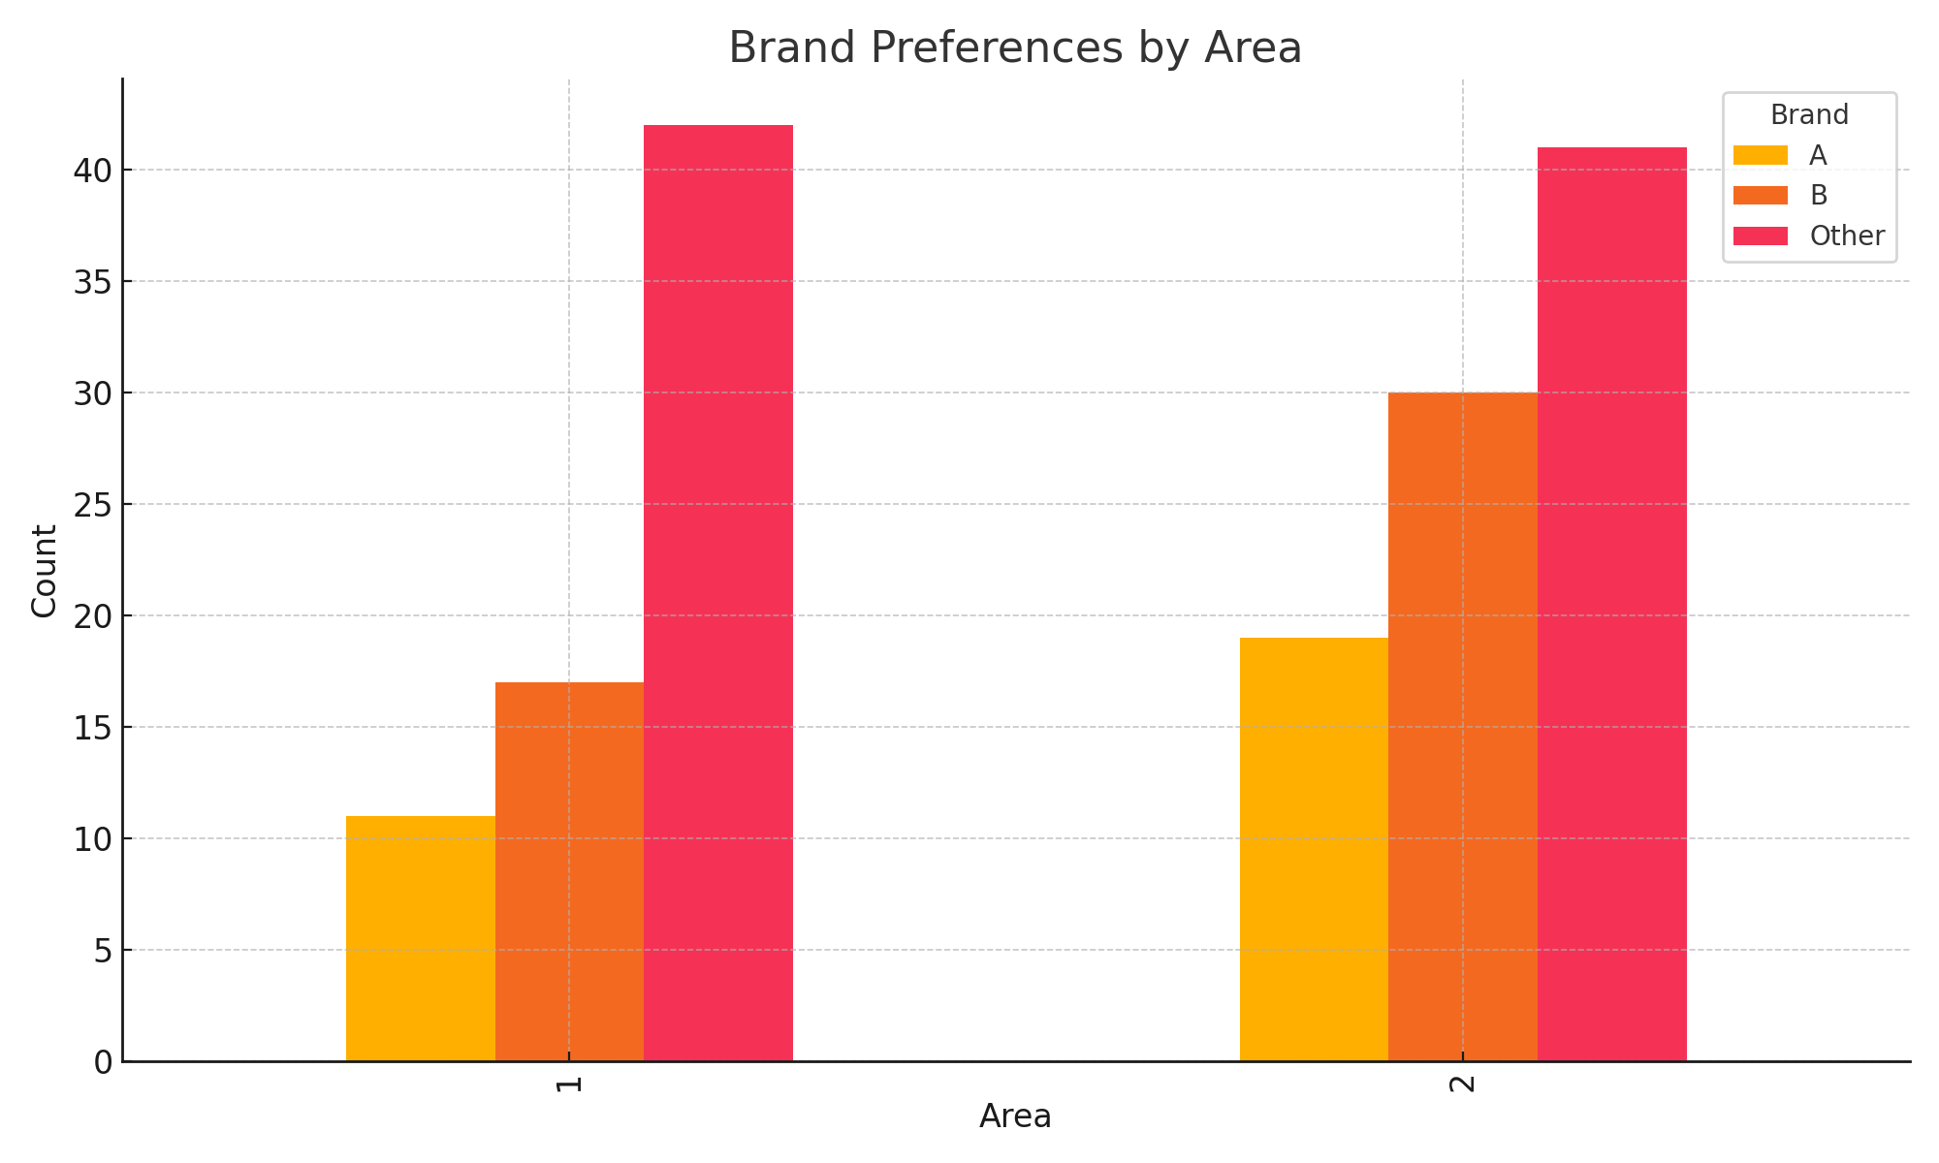

A bar chart was created showing the frequency of brand preferences across the three areas.  
- Brand B is the most preferred overall.  
- Area 1 shows a more even distribution of preferences.  
- Area 3 has the highest proportion of 'Other' responses, possibly indicating brand fragmentation or dissatisfaction.  
This visualization helps identify regional differences in brand loyalty, valuable for targeted marketing.

# Exercise 9.2D: Histogram – Income Distribution by Gender

Dataset Used: Superplus.xlsx

Variables: Sex (M/F), Income (continuous)

Chart Type: Histogram (Interval/Ratio data)

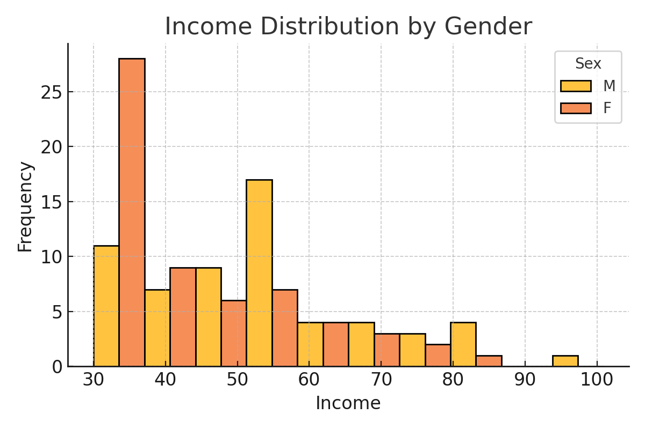

Histograms were generated for male and female income distributions:  
- Male income appears slightly higher on average, but with a wider spread and potential right-skew.  
- Female income has a more concentrated distribution and a smaller spread.  
This suggests possible gender differences in earning levels and income variability, important for equity analysis or program planning.

# Exercise 9.3B: Boxplot – Weight Loss Comparison (Diet A vs B)

Dataset Used: Diets.xlsx

Variables: Diet (A or B), Wtloss (kg lost)

Chart Type: Boxplot (Comparative, interval data)

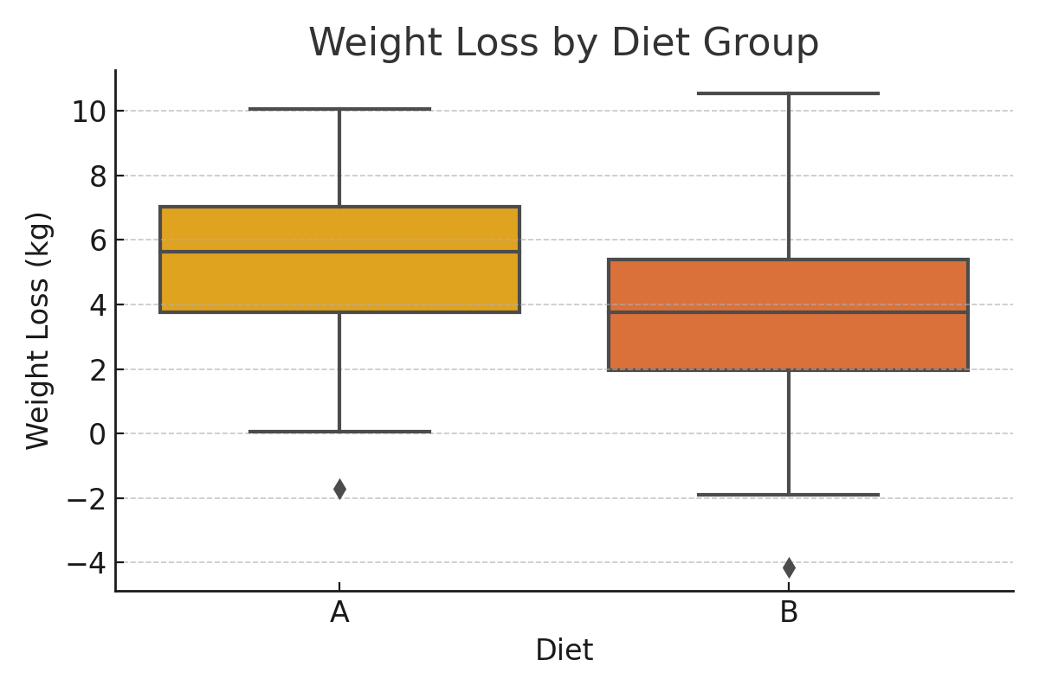

The boxplot shows:  
- Median weight loss was slightly higher for Diet B.  
- Diet A had a wider interquartile range (more variability).  
- No extreme outliers were present in either group.  
Although both diets resulted in weight loss, Diet B may be more consistent, while Diet A showed more variability between participants.

# Overall Conclusion

This worksheet highlights how chart selection matters:  
- Bar charts for categorical comparison  
- Histograms for distribution patterns  
- Boxplots for comparing spread and central tendency  
Each chart provided a unique lens to understand and interpret different types of data effectively.